**3/20/2014 Nokia 5110 LCD Display**

1. Project Reference Number / Title:

- 20140328 Nokia 5110 LCD Display

2. Link to Hardware Order:

-[84*48 84x84 LCD Module White backlight adapter PCB for Nokia 5110 Arduino ESY1](http://www.ebay.com/itm/121273083339?ssPageName=STRK:MEWNX:IT&_trksid=p3984.m1497.l2649)

121273083339)

Sale date: 03/27/14

* 100% Brand New.
* 4-board LED, backlight, light uniformity
* PCB Size: 45 (mm) x 45 (mm)
* The corners were positioning holes, along with two rows of the upper and lower connection port, ranked as follows:
* VCC - power input ( 3.3v )
* GND - Ground
* SCE - Chip Select
* RST - Reset
* D \ C - data / instruction selection
* DN - Serial Data Line
* CLK - Serial Clock Line
* LED - backlit console
* Drivers will be provided:
* NOKIA5110 FOR 51 (keil c)
* NOKIA5110 FOR PIC (picc)
* NOKIA5110 FOR AVR (gcc)
* NOKIA5110 FOR STM32 (keil for arm)
* NOKIA5110 FOR MSP430
* NOKIA5110 FOR LPC2148

3. Other Documentation:

-This is a library for our Monochrome Nokia 5110 LCD Displays  
  
 Pick one up today in the adafruit shop!  
 ------><http://www.adafruit.com/products/338>  
  
These displays use SPI to communicate, 4 or 5 pins are required to   
interface  
  
Adafruit invests time and resources providing this open source code,   
please support Adafruit and open-source hardware by purchasing   
products from Adafruit!  
  
Written by Limor Fried/Ladyada for Adafruit Industries.   
BSD license, check license.txt for more information  
All text above must be included in any redistribution  
  
To download. click the DOWNLOADS button in the top right corner, rename the uncompressed folder Adafruit_PCD8544. Check that the Adafruit_PCD8544 folder contains Adafruit_PCD8544.cpp and Adafruit_PCD8544.h  
  
Place the Adafruit_PCD8544 library folder your <arduinosketchfolder>/libraries/ folder. You may need to create the libraries subfolder if its your first library. Restart the IDE.  
  
You will also have to download the Adafruit GFX Graphics core which does all the circles, text, rectangles, etc. You can get it from  
<https://github.com/adafruit/Adafruit-GFX-Library>  
and download/install that library as well

4. Link to Source Documentation/ Actual Documentation:

[Adafruit-PCD8544-Nokia-5110-LCD-library](https://github.com/adafruit/Adafruit-PCD8544-Nokia-5110-LCD-library)

-

5. Wiring Documentation:

-

# **Wiring**

 [LADY ADA](https://learn.adafruit.com/users/adafruit2)

The LCD runs at 3.3V so you'll need to use a level shifting chip to use with a 5V microcontroller. The following will assume that is the case. If you're running a 3.3V microcontroller system, you can skip the level shifter.

We'll assume you want to use this in a breadboard, take a piece of 0.1" header 8 pins long and insert it into a breadboard.

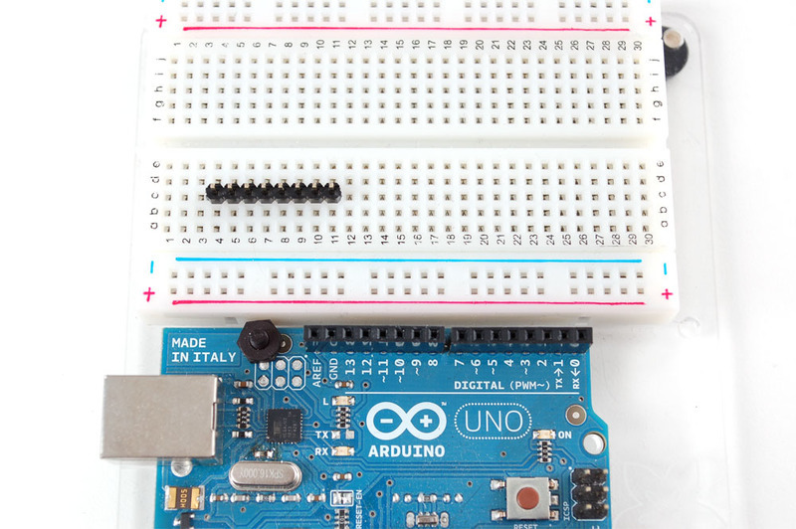

Slide either side of the LCD onto the header, the 'thicker' end is the top.

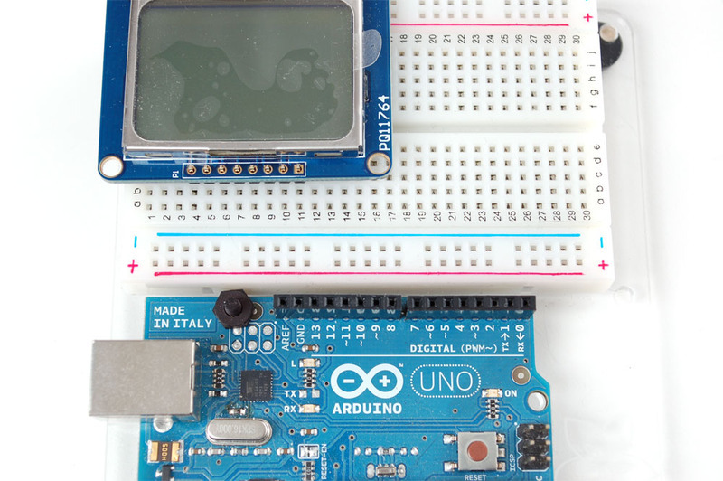

Solder all the pins.

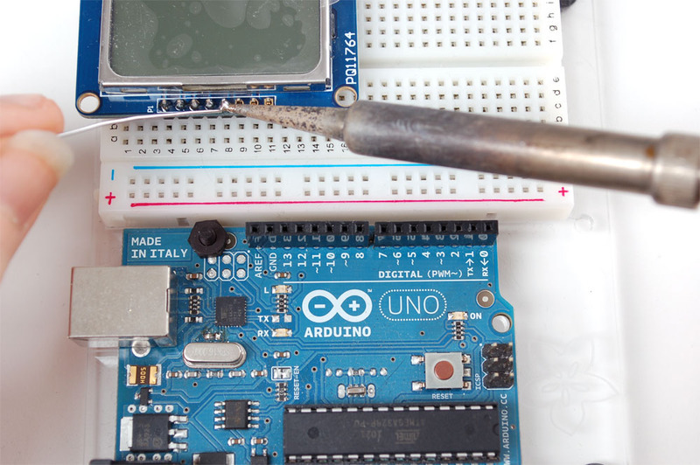

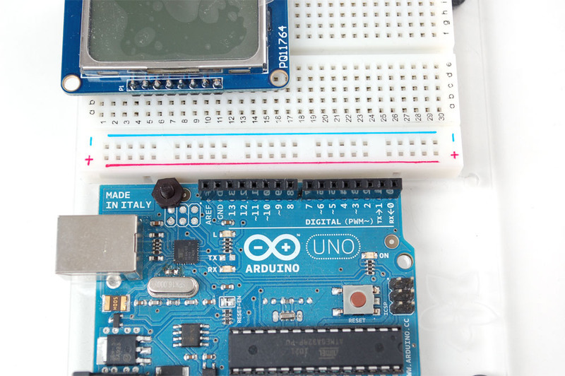

Place the level shifter chip off to the side. Pin 1 is on the left here.

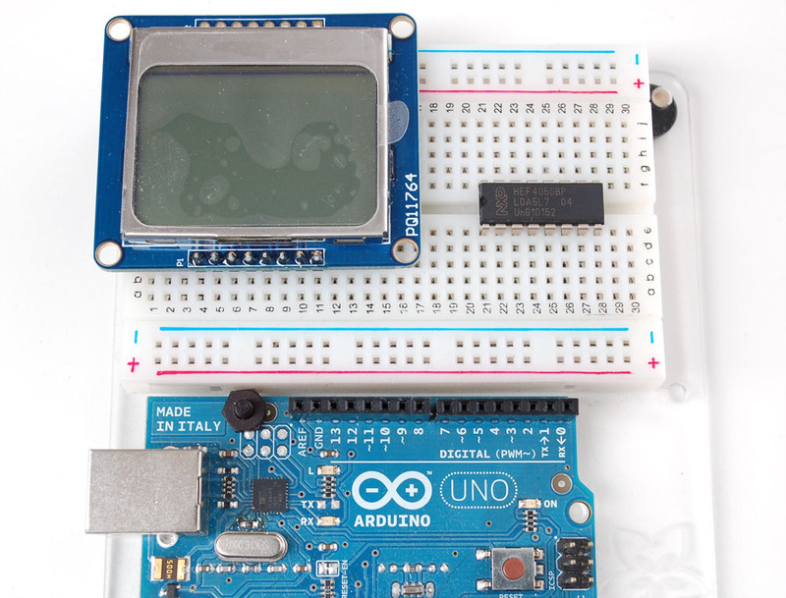

We'll start with the power lines. the system must be powered by 3.3V so red here is connected to the 3V pin from the Arduino. Ground is black.

* Connect pin 1 of the 4050, the LCD **VCC** pin and the LCD **backlight** pin to 3.3V.
* Connect pin **8** of the 4050 and the **GND** pin of the LCD to ground.

Verify you see the backlight LEDs light up

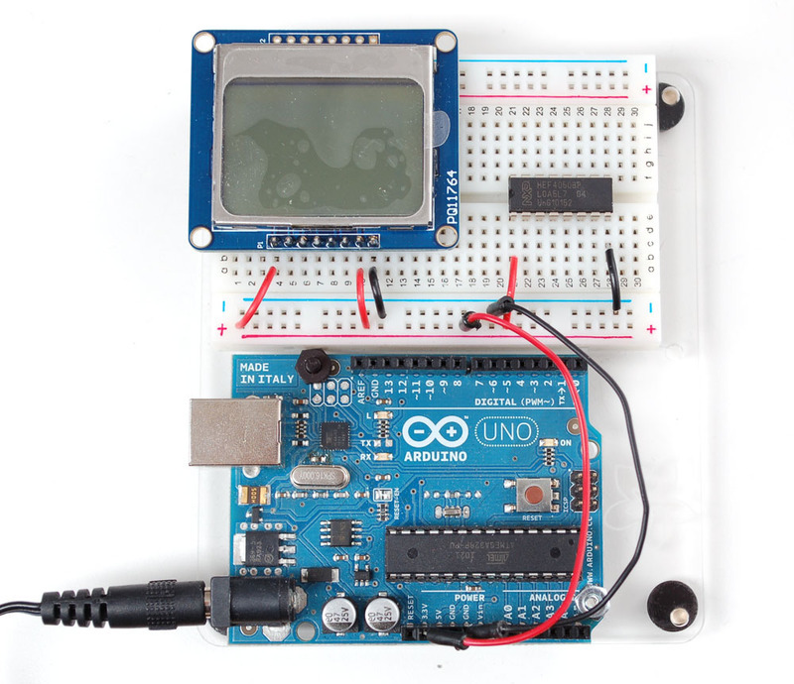

Next we'll start wiring up the data lines.

* Connect the **RST** (reset) pin of the LCD (orange wire) to pin **2** of the 4050
* Connect the **CS** (chip select) pin (yellow wire) to pin **4**of the 4050.
* Connect the **D/C** (data/command) pin (green wire) to pin **6** of the 4050.

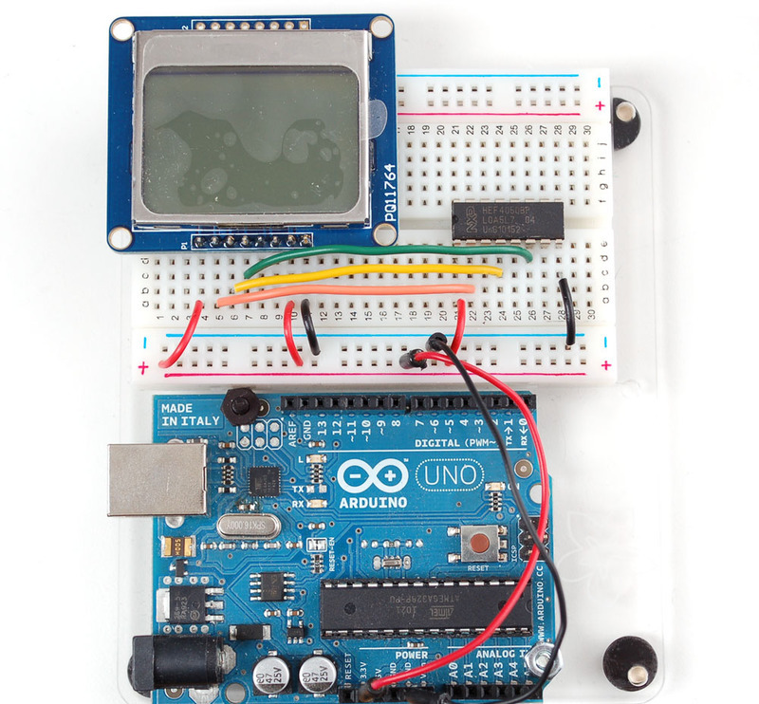

Next, connect:

* **DIN** (data in) pin (blue wire) to pin **15** of the 4050
* **CLK**(clock) pin (purple wire) to pin **12** of the 4050.

Then we can connect the data lines from the arduino to the LCD. We can use **any** 5 pins but you may want to start with our example first.

* Arduino pin **3** (orange) goes to pin **3** of the 4050.
* Arduino pin **4** (yellow) goes to pin **5** of the 4050.
* Arduino pin **5** (green) goes to pin **7** of the 4050.
* Arduino pin **6** (blue) goes to pin **14** of the 4050.
* Arduino pin **7** (violet) goes to pin **11** of the 4050.

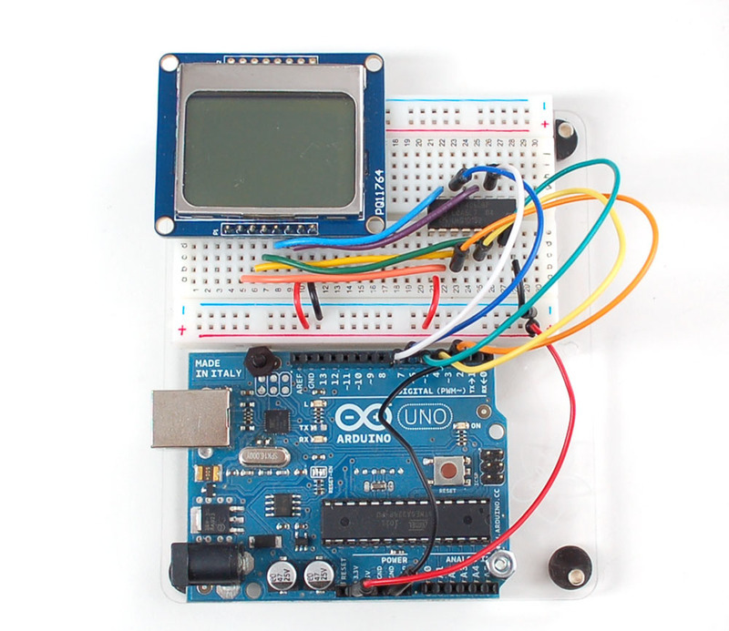

Now you are ready to test!

[POWER REQUIREMENTS](https://learn.adafruit.com/nokia-5110-3310-monochrome-lcd/power-requirements)[TESTING](https://learn.adafruit.com/nokia-5110-3310-monochrome-lcd/testing)

Last updated on 2014-04-10 at 04.08.23 PMPublished on 2012-12-17 at 11.39.04 PM

6. ---------------- Project Code: (text format) START -------------------

7. --------------- Project Code: (text format) END -----------------------